

Wee Kim Wee School of Communication and Information

**CI6225: Enterprise Applications Development**

**Individual Assignment-2 Report**

**Pet Online Shop System**

*Submitted by*

PHU WAI PAING (G1901561C)

**1.0 Introduction**

Pet Online Shop System is a stand-alone spring boot web application that can be used to buy puppies from online without meeting the sellers face to face. The system is deployed by integrating spring boot with hibernate for the back-end and by using Thymeleaf, Java-based library for the front-end. In this system, the dao class will have sessionFactory injected which will be used to create hibernate session and connect to MySQL database.

**2.0 Project Structure**

Following is the project structure. The system has controllers and dao layers. And also, application.properties file contains configurations related to datasource.

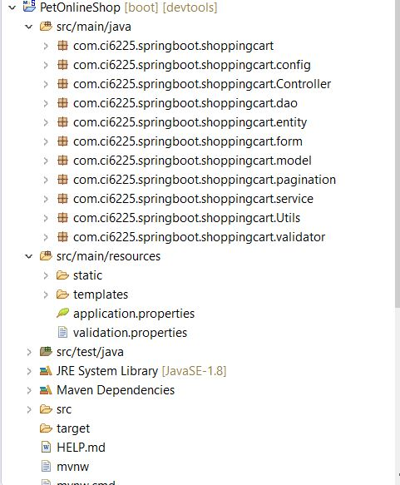

Figure: Project Structure

**3.0 List of System Features**

In this system, there are two user roles- admin part and customer part. The functions and features for each user role are:

**3.1 Features of admin role**

3.1.1 Login

Inputs -Username

-Password

3.1.2 Edit/update products (puppies) Information

Inputs -Name

-Price

-Gender

-Image

3.1.3 Create new products (puppies)

Inputs -Code

-Name

-Price

-Gender

-Image

3.1.4 View customers’ order lists

3.1.5 View Details order lists

3.1.6 Put products (puppies) into the cart

3.1.7 Delete products (puppies) from the cart

3.1.8 Fill the personal information for check out

3.1.9 View the products (puppies) that are already put into the cart for confirmation

3.1.10 Check out and put the order

3.1.7 Logout

**3.2 Features of customer role**

3.2.1 View the products (puppies) list

3.2.2 Put the product into the cart

3.2.3 Delete the product from the cart

3.2.4 Fill the personal information for check out

3.2.5 View the products that are put into the cart for confirmation

3.2.6 Put and buy the order

**4.0 Technical Design**

Spring boot is used as a core technology in this system. And, the needed configurations and dependencies are added to integrate hibernate, adding Web, JPA and MySQL dependencies.

**4.1 Environment Setup used for Development**

In this project, Eclipse is mainly used as an IDE for writing codes. For database, MySQL Server 8 is used as a database server and MySQL Workbench is used to connect and manage the database server.

|  |  |
| --- | --- |
| Development Environment | Version |
| Eclipse IDE | 4.13.0 |
| My SQL Server | 8.0.17 |
| My SQL workbench | 8.0.17 |
| Browser (Firefox) | 75.0 |

**4.2 Frameworks and Libraries used for Development**

Apache Maven is used as a build tool and other dependencies such as framework and libraries are added for spring boot, mysql, thymeleaf in pom.xml.

|  |  |
| --- | --- |
| Frameworks and Libraries | Version |
| Apache Maven | 2.2.6.RELEASE |
| Apache Tomcat | 9.0.33 |
| Spring Boot Framework | 2.2.6.RELEASE |
| MySQL connector Java | 8.0.19 |
| Commons File Upload | 1.4 |
| Commons Validator | 1.6 |
| Hibernate ORM core | 5.4.12 Final |
| Thymeleaf | 2.2.6 RELEASE |

**4.3 Entity Relationship Diagram**

The system has four database tables. Account, products and orders tables simply store the information of products, orders, customers and admin. Order_details table is connected with orders and products tables for one to many relationship where products id and orders id become the foreign keys to store information of products and orders.

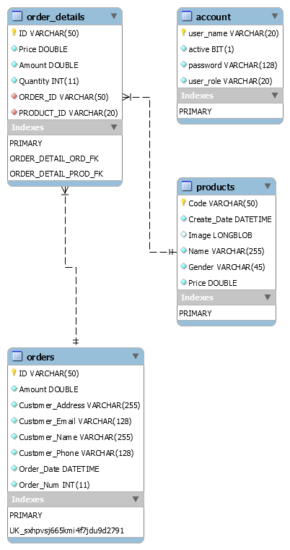

Figure: ER Diagram

**4.4 Class Diagram**

The purpose of the diagram is to introduce customer, product, order, orderdetails, cart, etc. and relationship between them.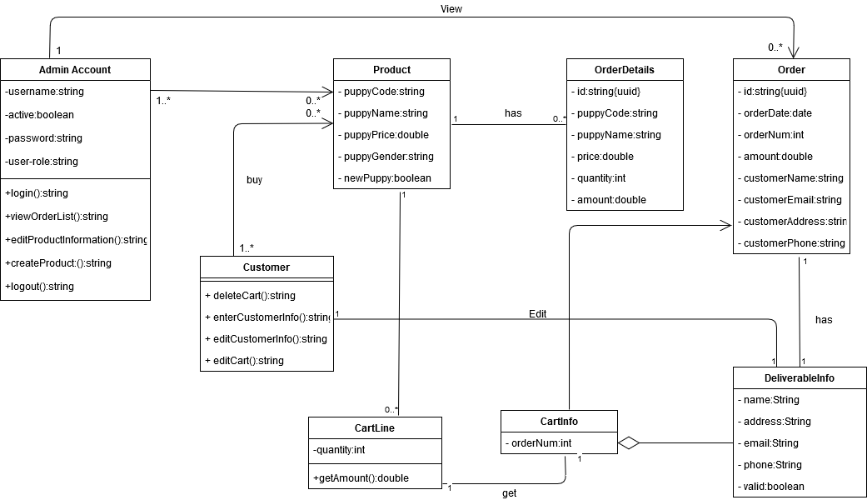

Figure: Class Diagram

**4.5 System Flowchart**

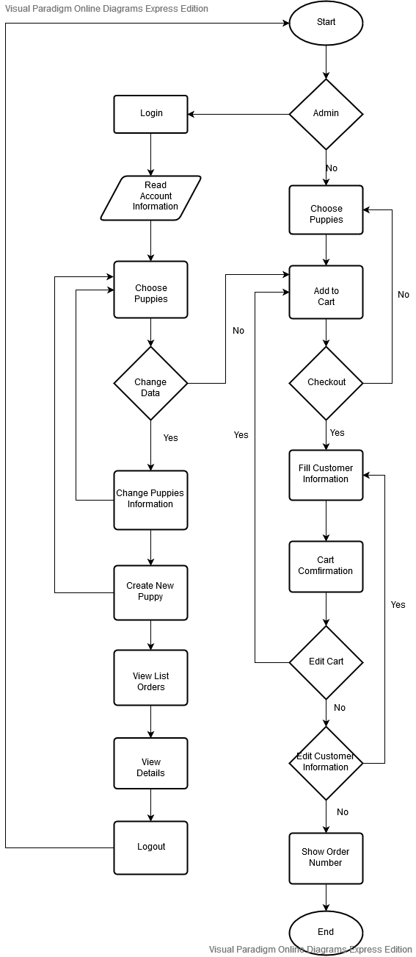

Figure: System Flowchart Diagram

**5.0 User Guide**

**5.1 User Guide for Customer**

The first step of the system is Welcome Page including Home button, Product List button, My Cart button and Admin Login.

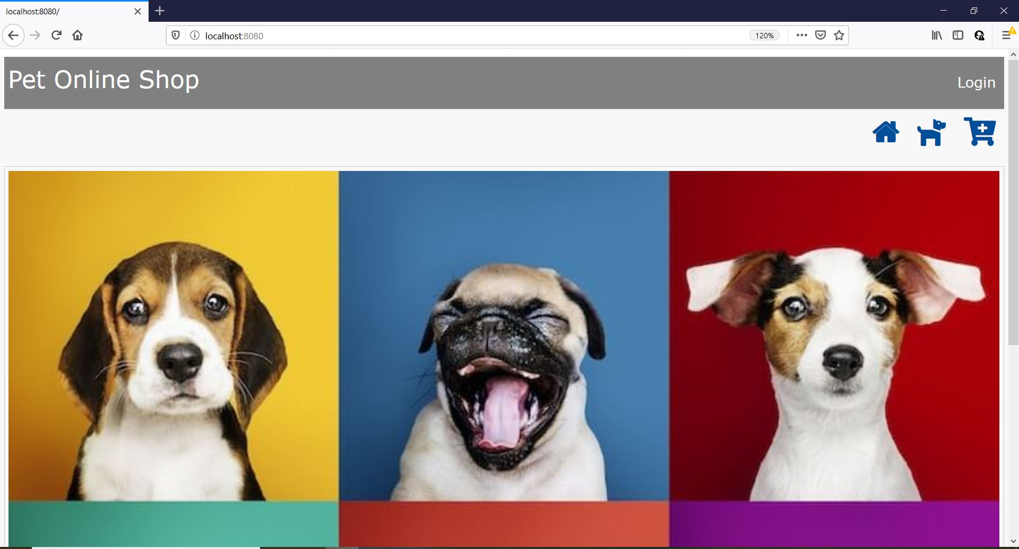

Figure: Welcome Page

When you clicks Product List 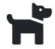 button, you will see available items. Each product list page will show only 6 items. The rest of the items will be shown by the system the time you clicks the pagination.

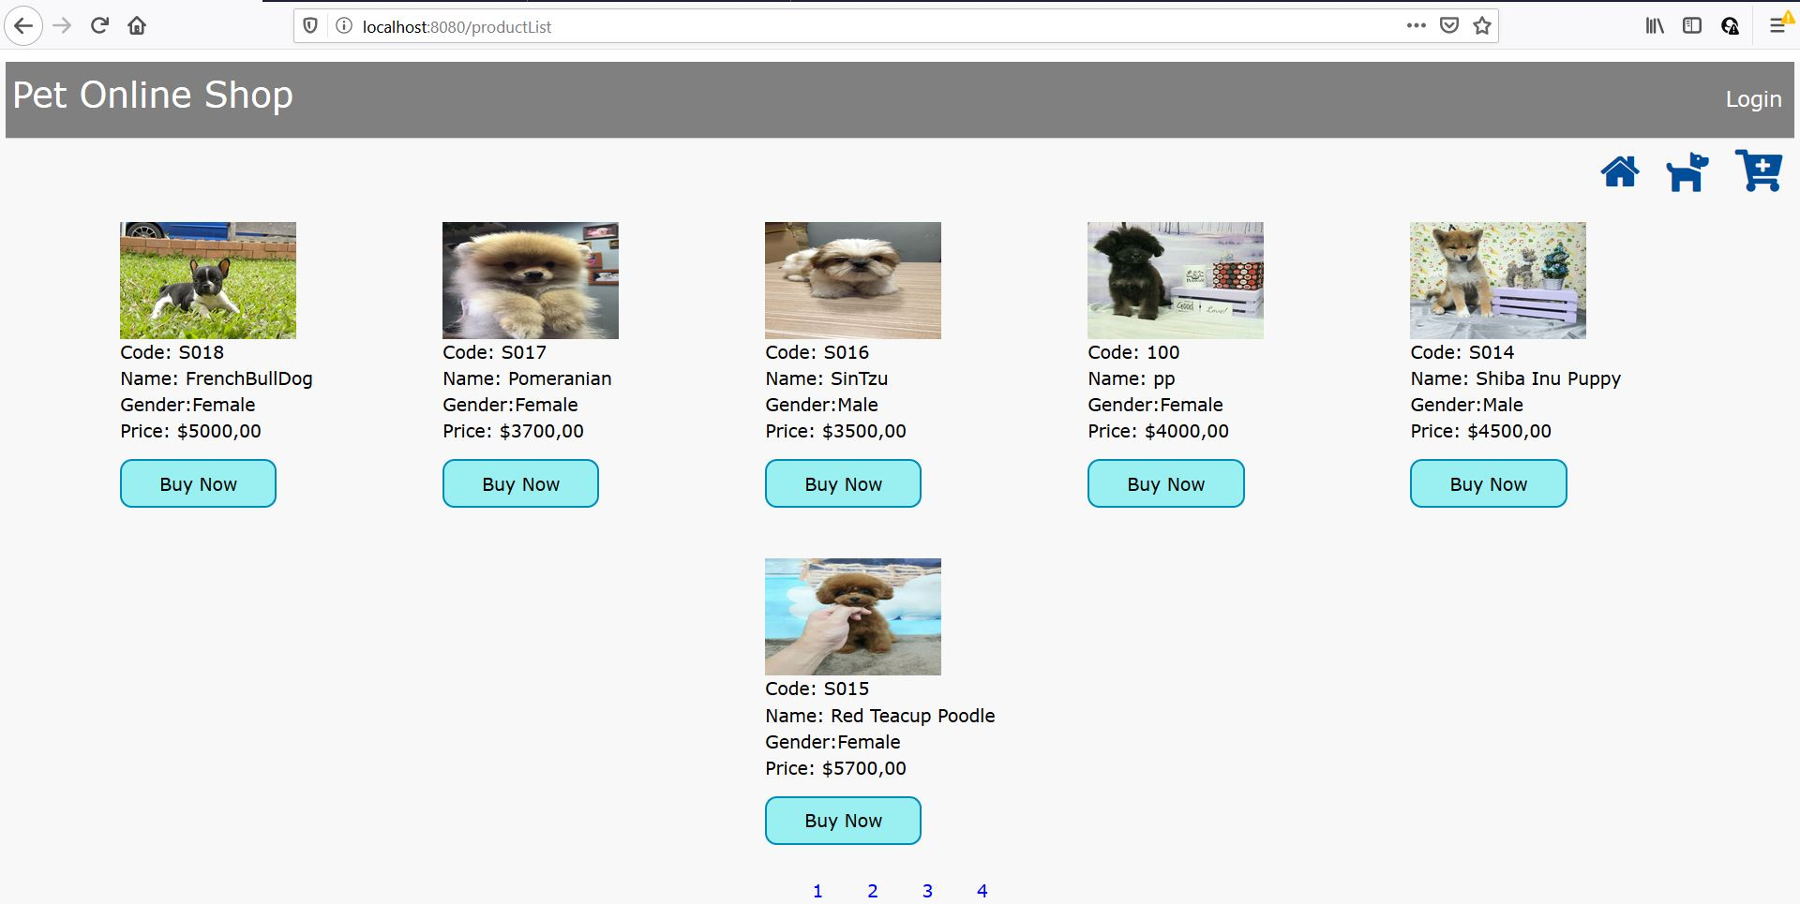

Figure: Product List Page

By clicking ‘Buy Now’ button, the system will go to  (My Cart) page and show the items you click in details. In that page, you can delete the selected item by clicking ‘Delete’ button. Then, you can go to ‘Product List’ page and can add another items again by pressing ‘Keep Buying’ Link or put the orders by pressing ‘Check Out’ Link.

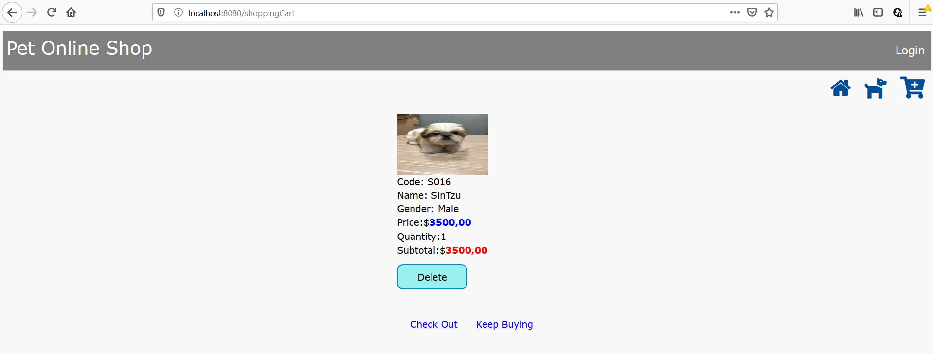

Figure: Adding item to ‘My Cart’ Page

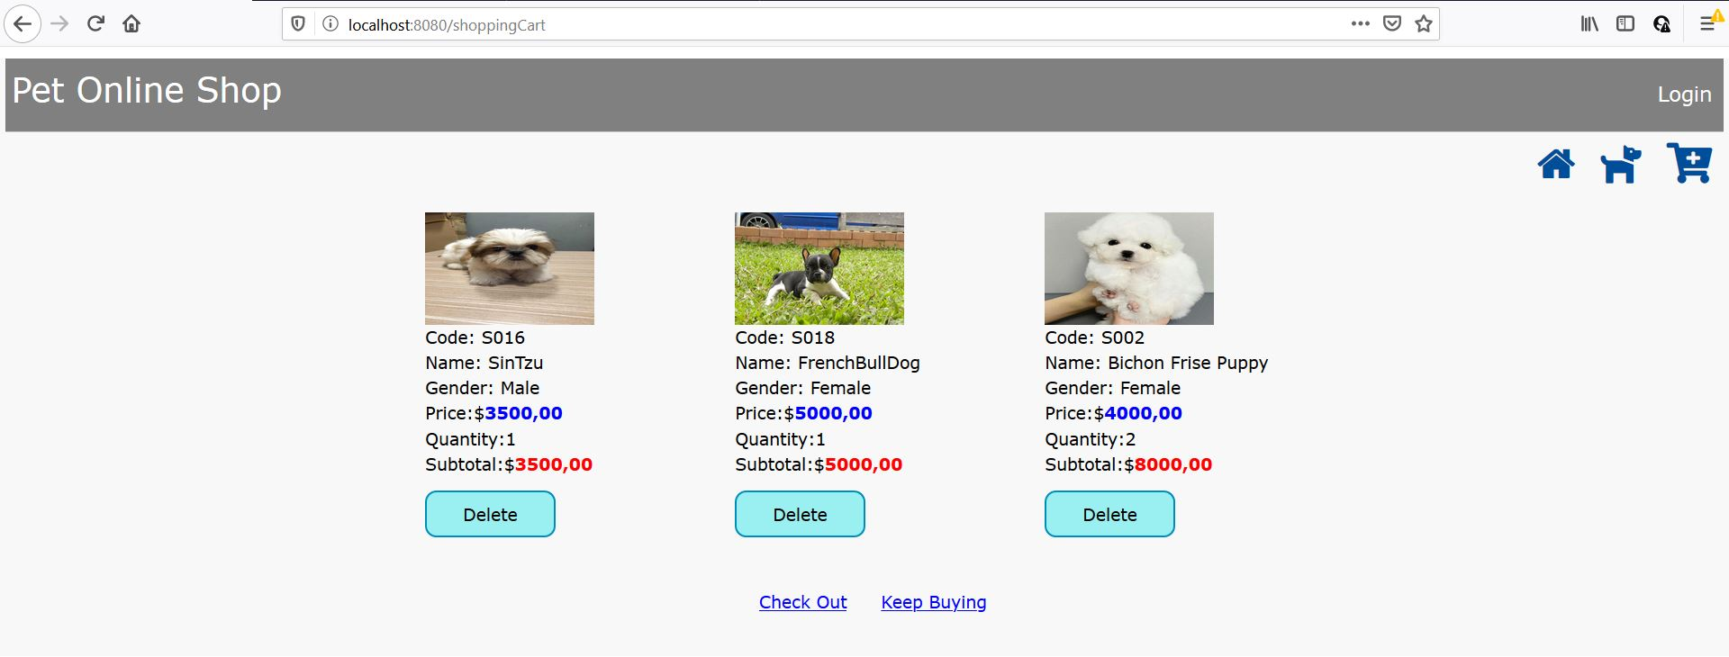

Figure: Adding more items to ‘My Cart’ Page

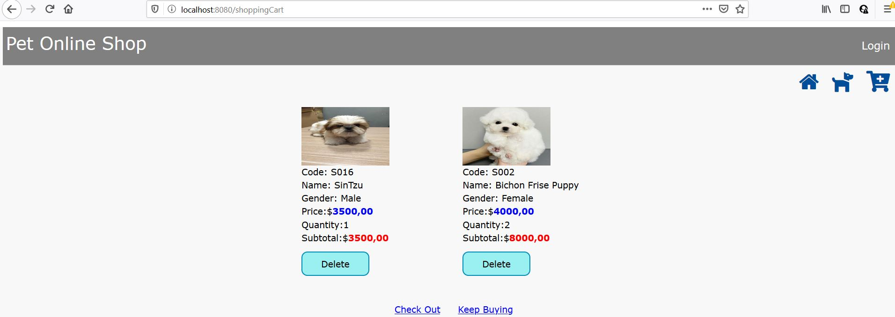

Figure: Delete the item from ‘My Cart’ Page

The next step is confirmation page. The purpose is that the system needs to know who is ordering for the later functions like deliverable function, order cancel function, etc. And, you also need to fill all fields in correct if you don’t, you will get the warnings to fill the correct one.

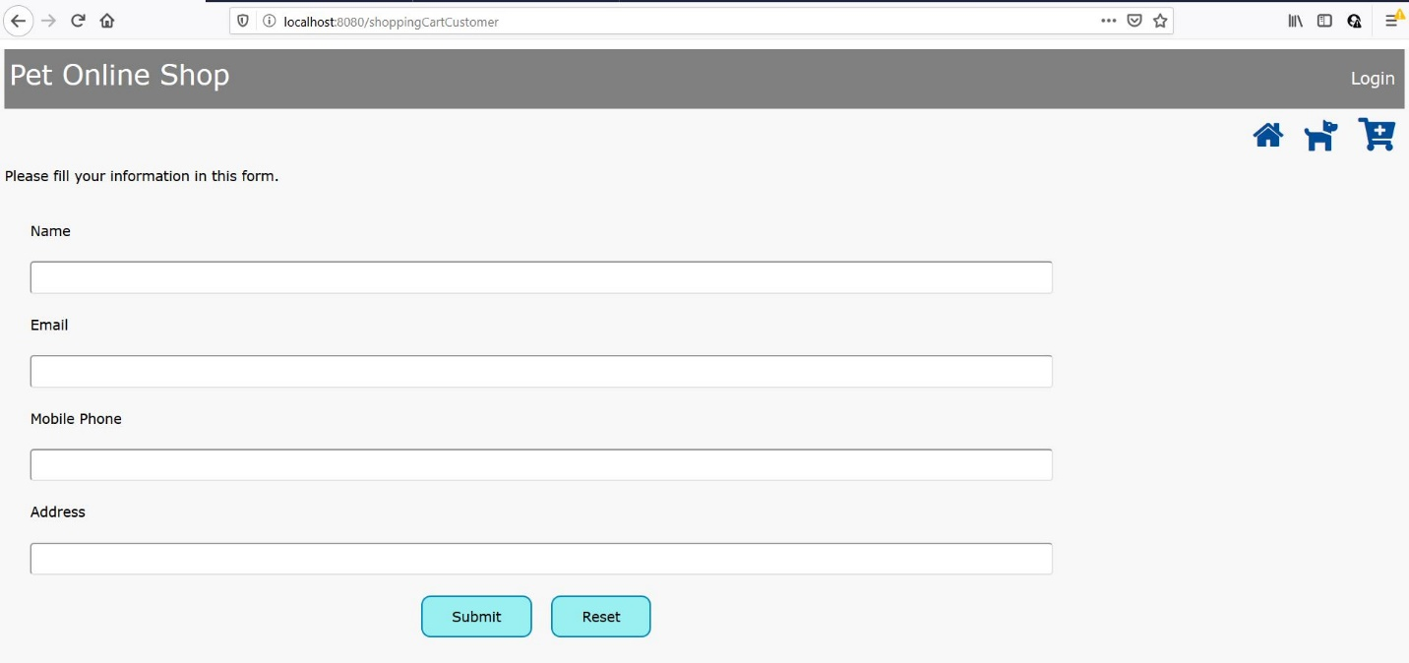

Figure: Filling Customer Information Page

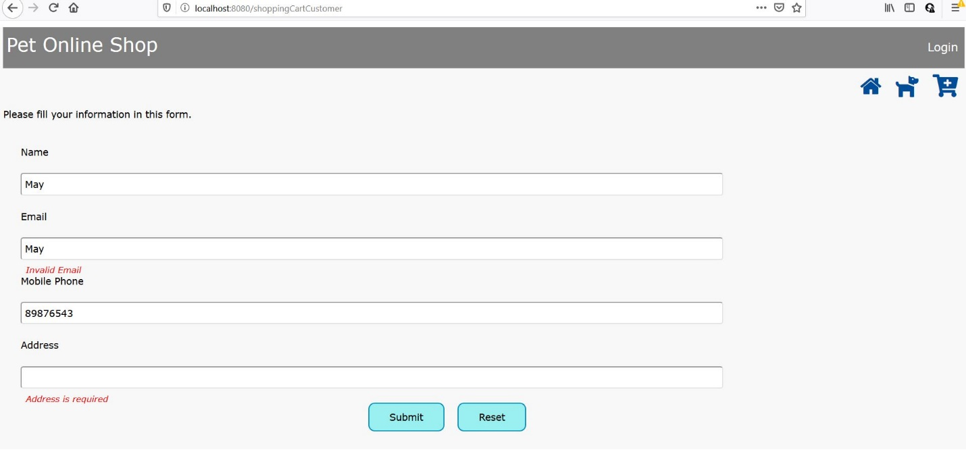

Figure: Error Notification

After filling all the personal information fields, click the ‘Submit’ button. The system will confirm the items you select and total amount. At this step, you can still change your mind. You can go to your cart and delete or edit the items again. After finishing that, click ‘Send’ button. Then, the system will give your order number that means your order has been confirmed.

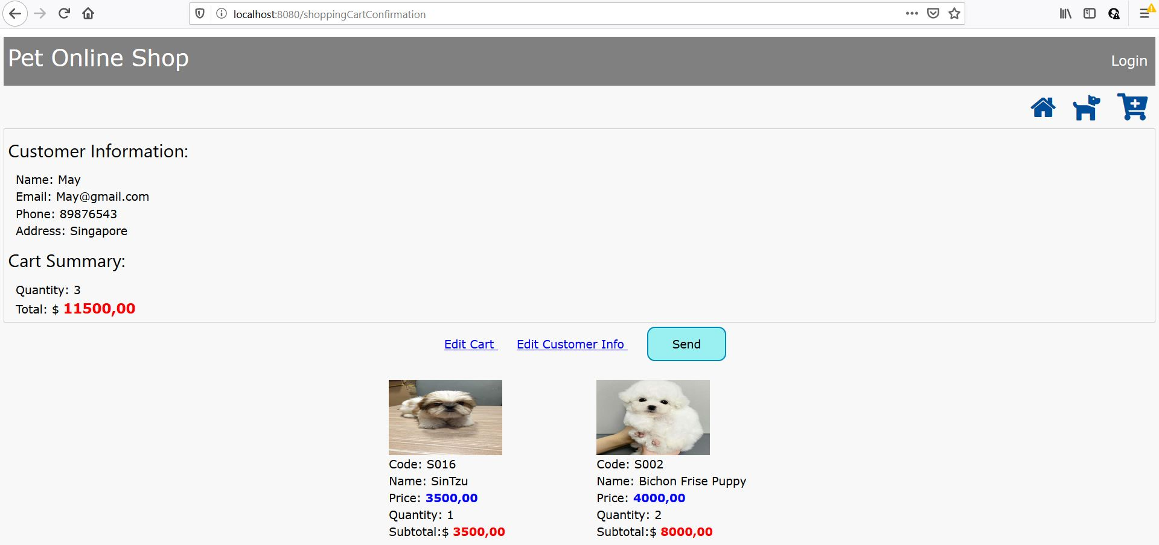

Figure: Order Confirmation Page

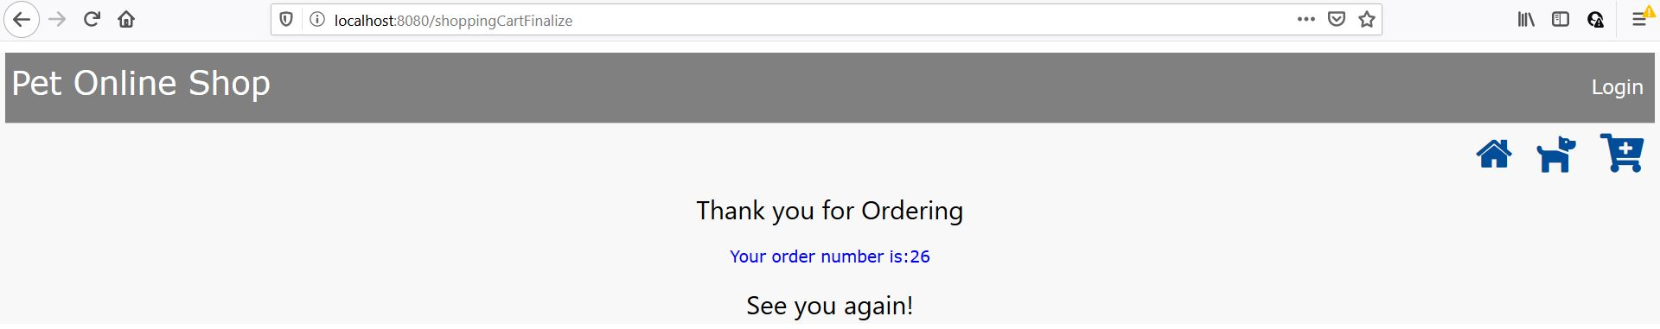

Figure: Final Page

5.2 User Guide for Admin

When you click ‘Login’ Link on navigation bar, you have to fill authenticated username and password if not, you will get the error page.

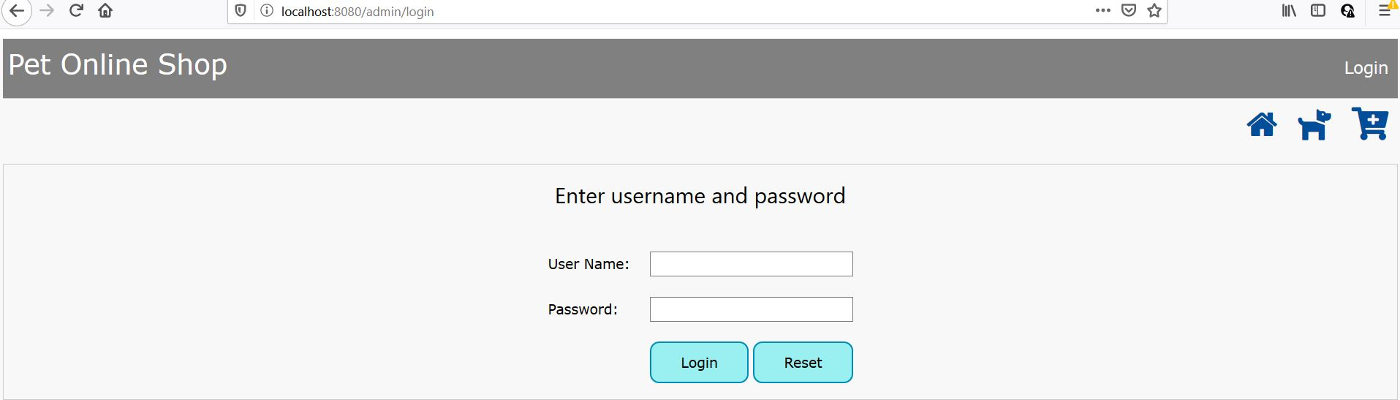

Figure: Admin Login Page

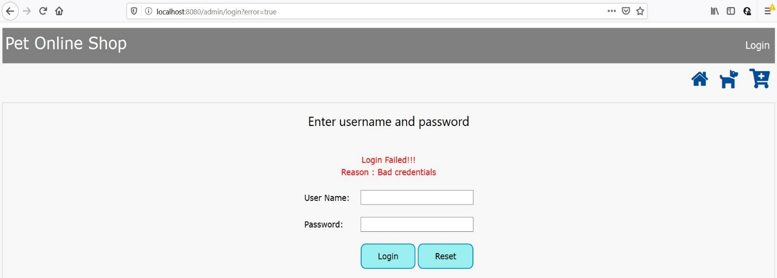

Figure: Unauthenticated Error

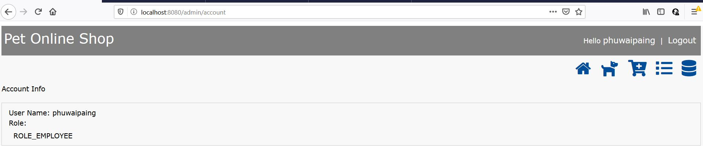

Figure: Login Successful Page

New icons and features are coming out in admin part. Admin view and edit the items by clicking 

(Product List) button. Admin can also buy the items (puppies) as like a customer and change the item information like increase/decrease the price, change the name or the image etc.

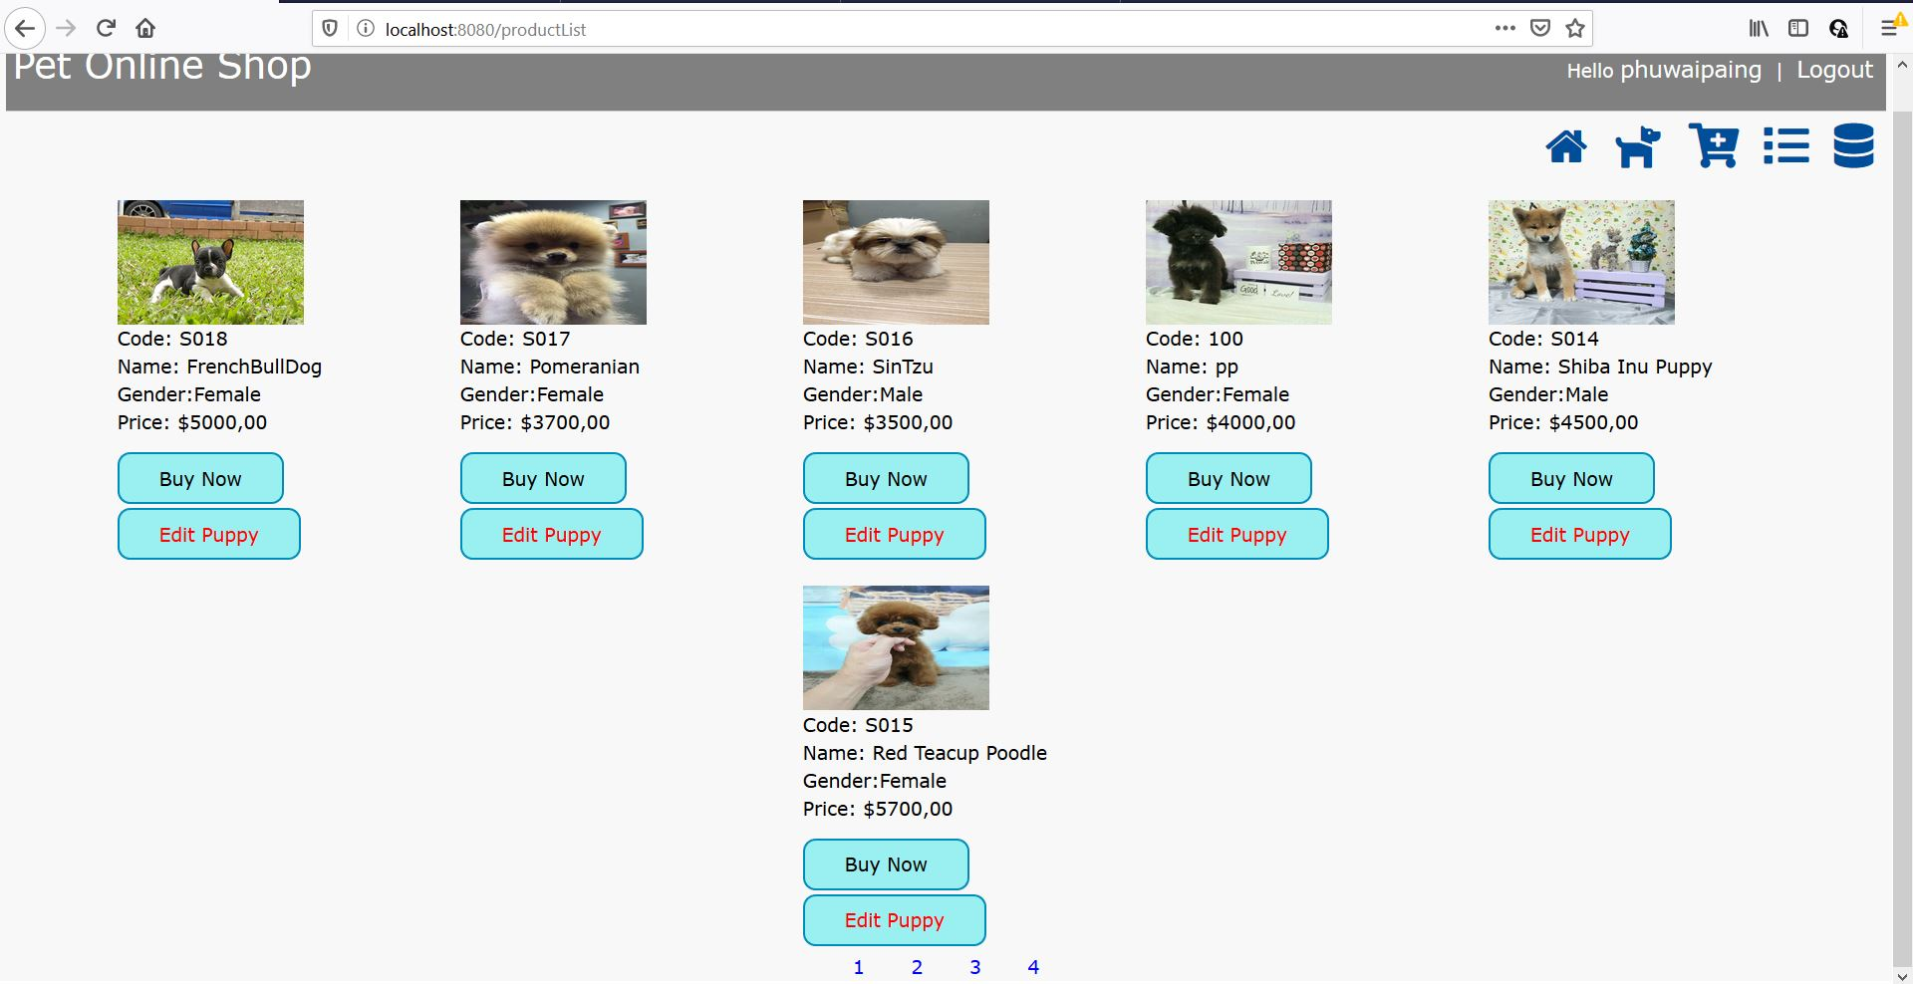

Figure: Admin Product List Page

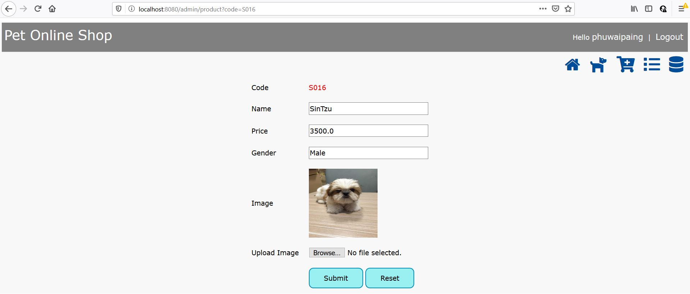

Figure: Edit/update the information of the current item

If the admin forgot to fill one of the fields, the system will show validation errors.

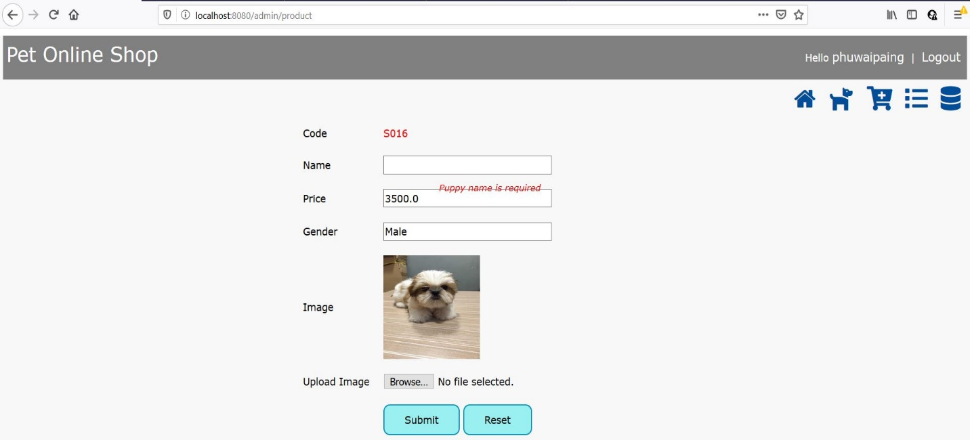

Figure: Validation Error illustration Page

Another features of admin are that the list of orders can be viewed by pressing 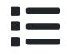 (Order List) button and can also view details of customer orders by clicking ‘view’ link inside the order list page.

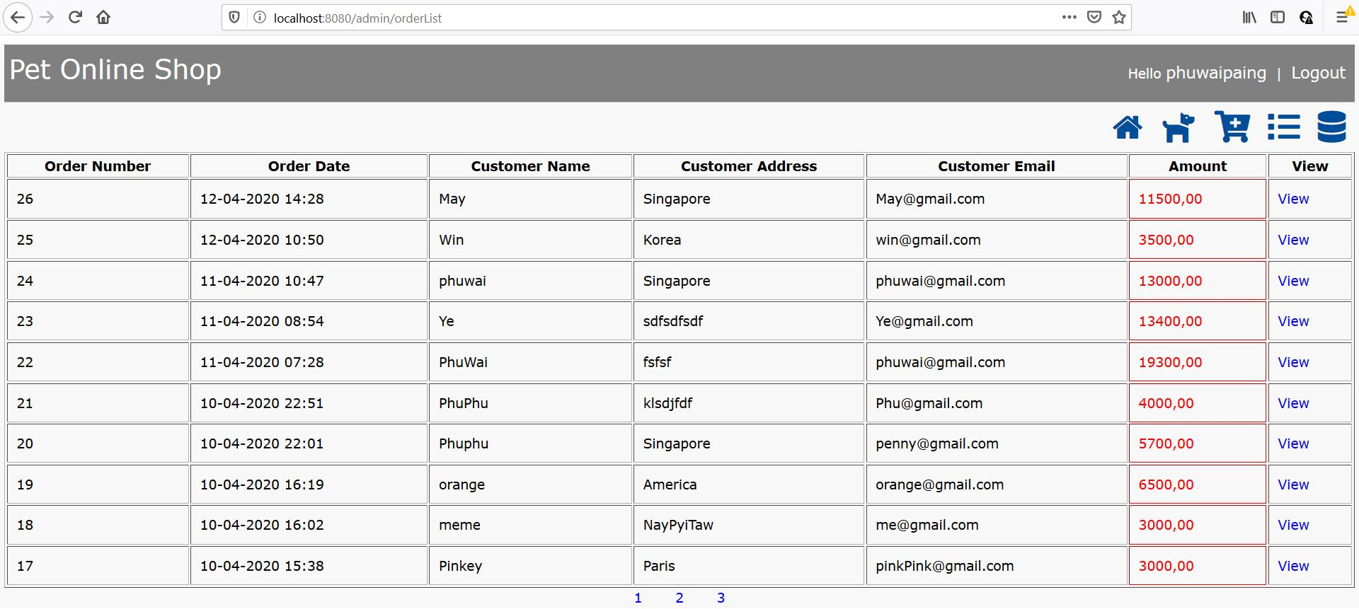

Figure: Order List Page

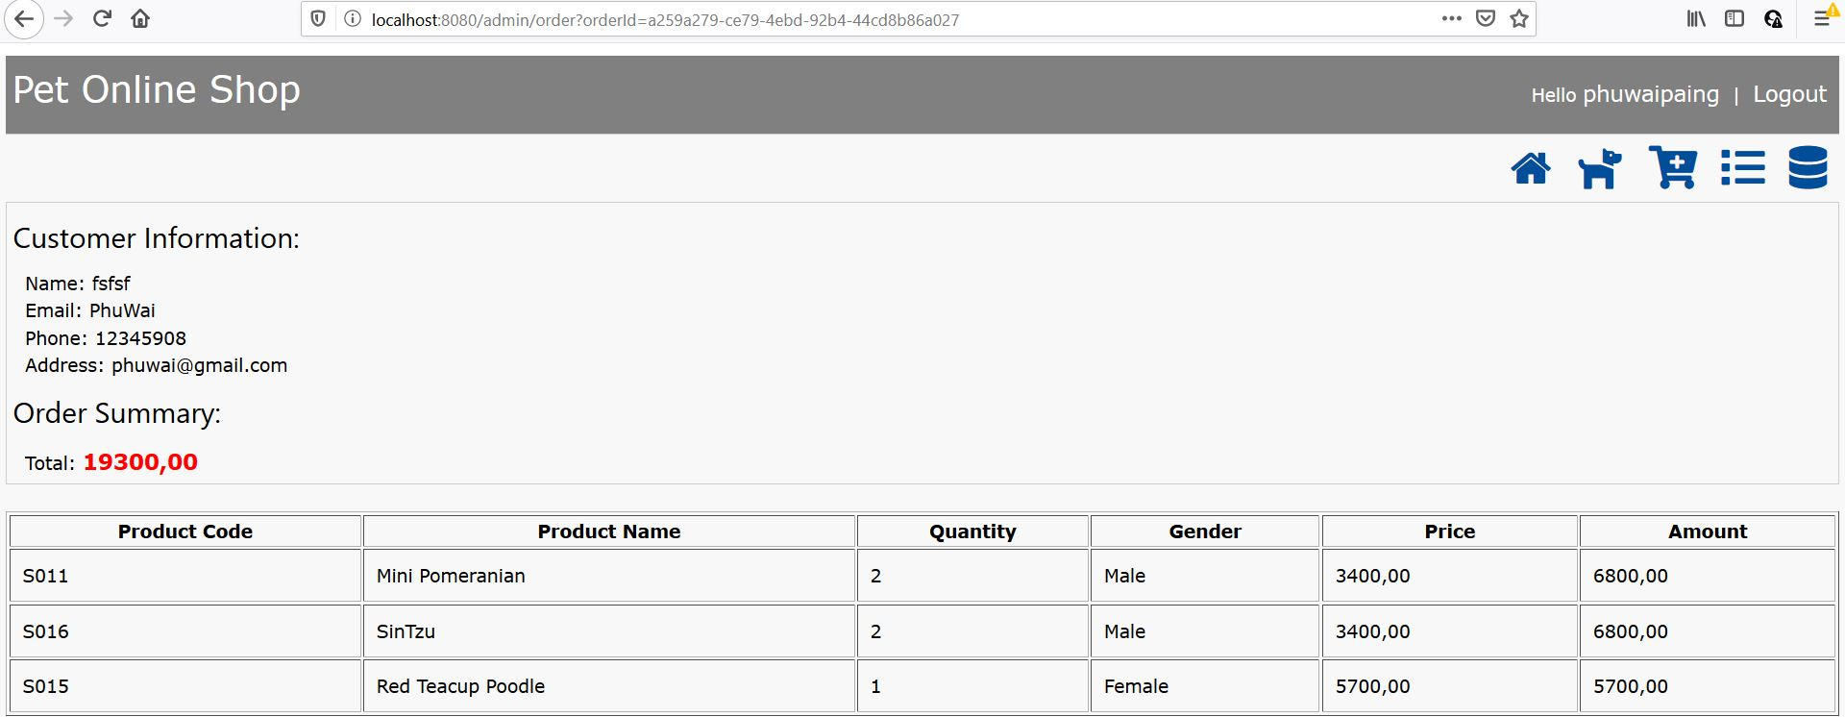

Figure: Order Details Page

The last feature of admin is creating new item by hitting 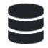 button.

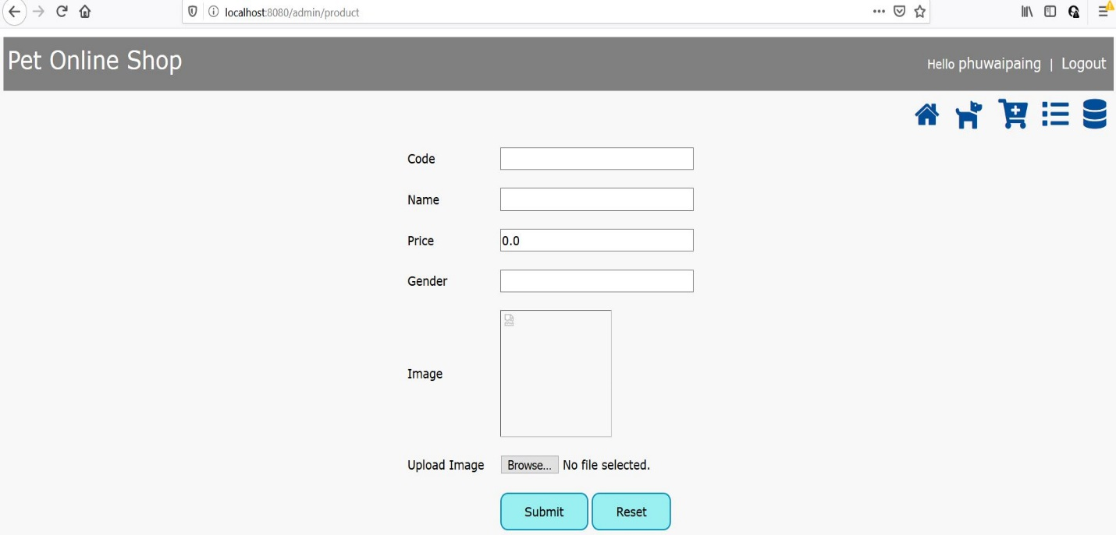

Figure: Creating new item Page

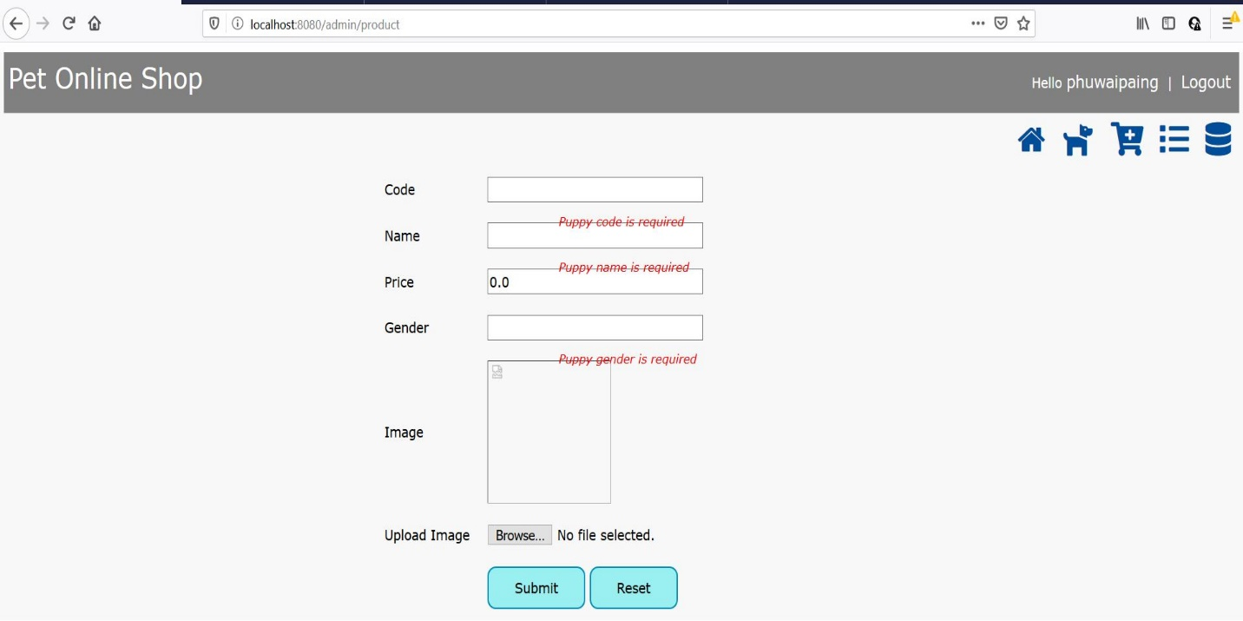

Figure: Error Validation Illustration Page

Logout Page is the same like the welcome page.



Figure: Logout Page